Project Report

**Title:** ShopForHome

**Members**:

1. Chaudhari Dipali Bajirao

# Problem Statement:

ShopForHome is a popular Store in the market for shopping the home décor stuff. Due to Covid19 all the offline shopping stopped. So, the store wants to move to the online platforms and wants their own Web application.

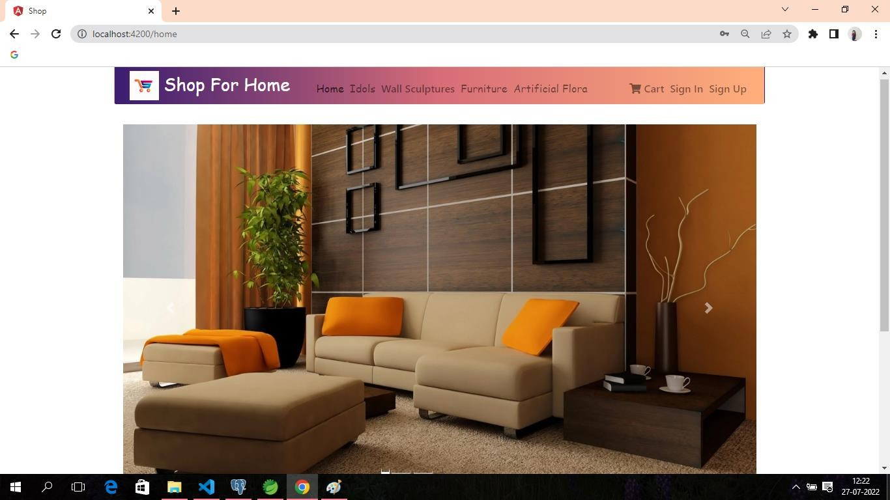

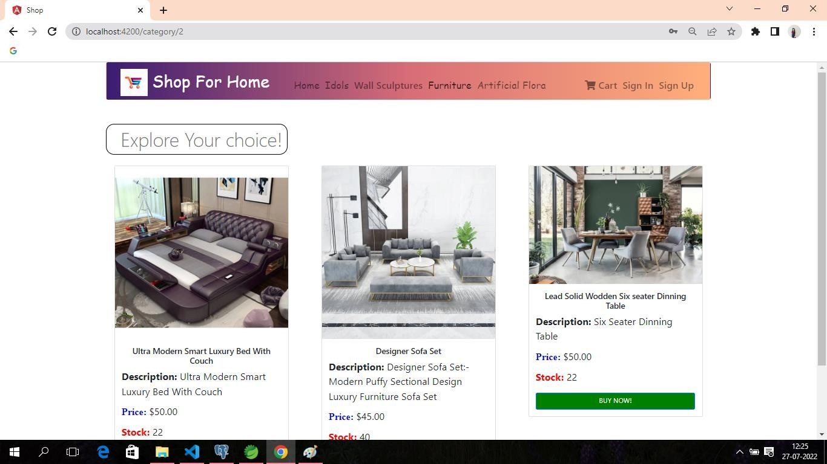

In today’s generation, most people are using technology for leading their lives and fulfilling their needs. In this generation, mostly people are using E- commerce Websites for shopping clothes, shoes, bags, furniture, etc. We have created a E-commerce Web application using Mean Stack technology. This technology consists of Angular, Spring boot 2,Postgresql. This applicationis fully responsive with admin login page, user login page, checkout, cart, wishlist, etc.

# Profile Page:

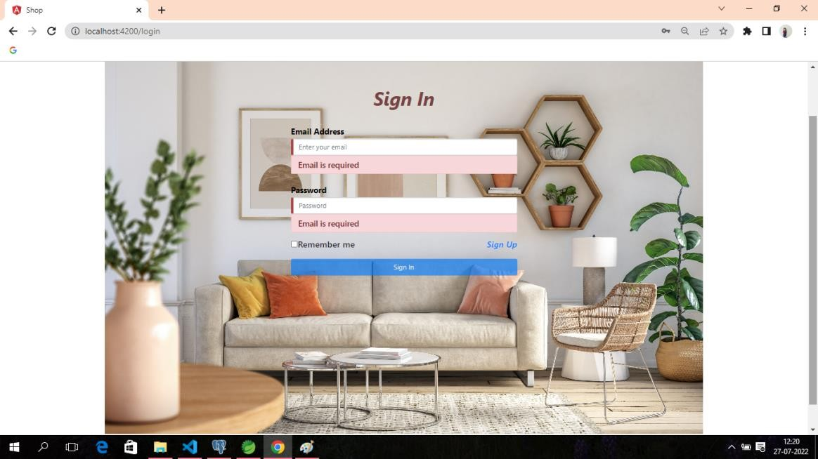

**Signup Page:**

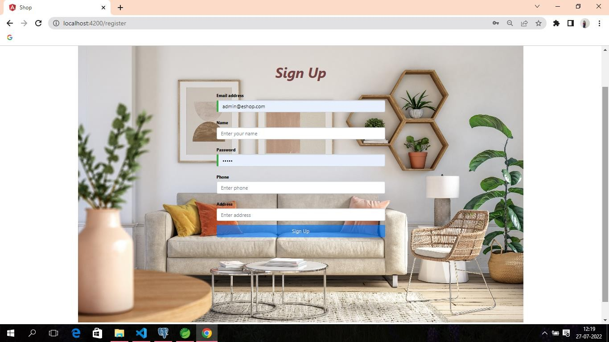

# Products Page:

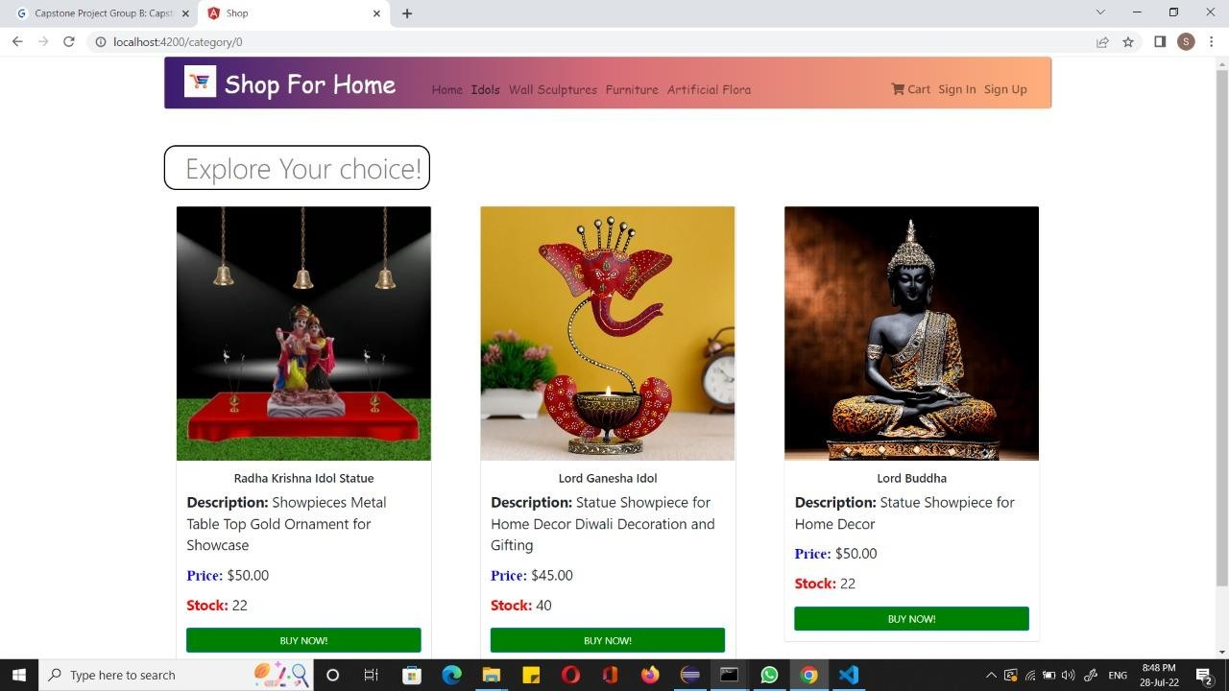

**About Us Page:**

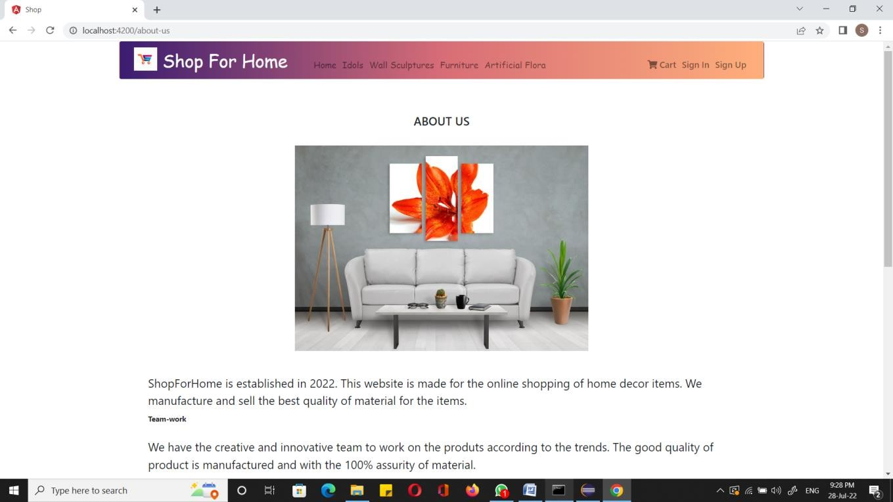

# Empty Cart Page:

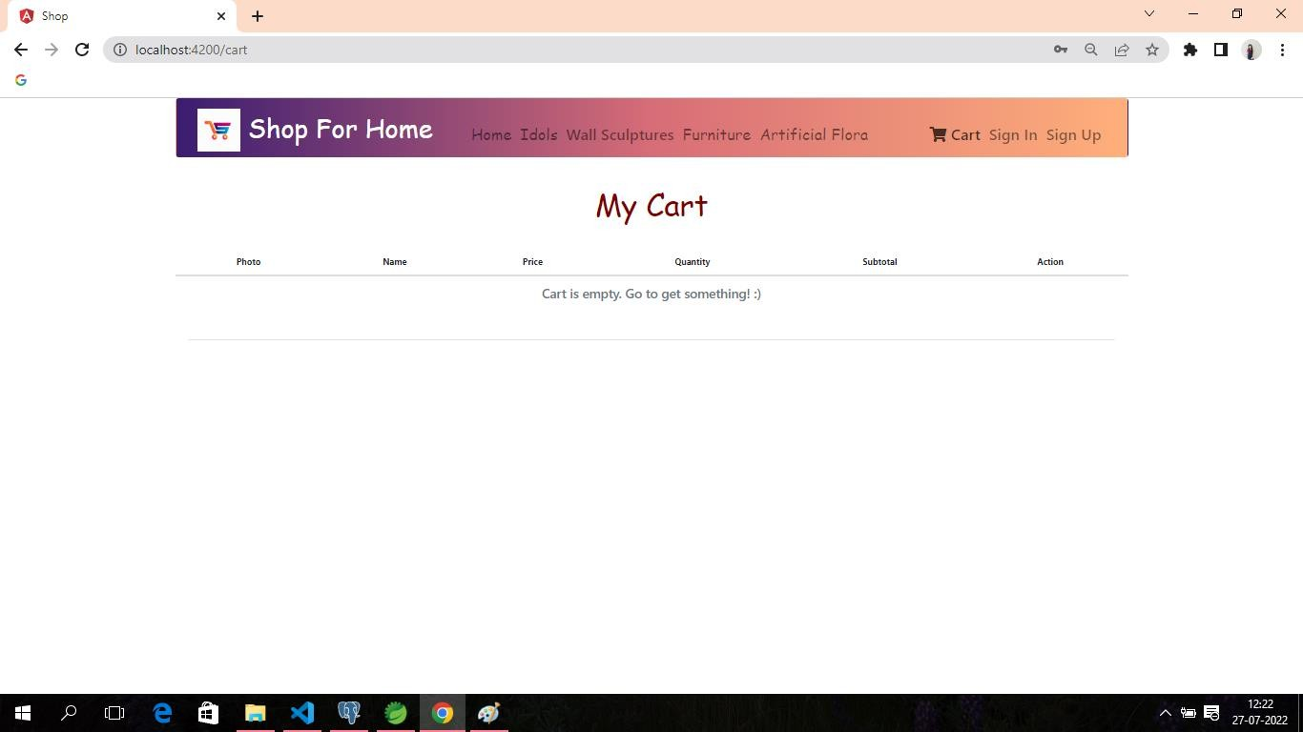

**THANK YOU!**